Introduction

As we all know, smart phone just shown up on market few decades ago but it has already changed people’s daily life. With the large amount of users some enterprise starts to develop application, which also called Apps run on smart phone to help people make their life easier.

Smart phone users are increasingly shifting to using apps as gateway to internet rather than traditional web browsers.(Qiang&Jeffrey&Alexandre&Zhouqing,JeffreyPang&Shobha,2011) App is become more and more important on smart phone than make call and receive call. Some of the apps even become the main reason of people using smart phone.

The most of KIWI may not have heard an application "Wechat" in New Zealand but Chinese may have already heard it tossed around a lot. Wechat is developed by Tecent in Mainland of China to provide mobile text and voice messaging service first release in 2011. The application is available on IPhone, Android, HTC, Widows phone and Symbian phone. By the end of 2014, Wechat has 438 active user in China and 70 million outside of China. Because of that large amount of user numbers, suddenly Wechat become the most popular and famous chatting tool among Chinese. For some people Wechat is not only just a chatting tool to help them chat or share photos to friend, however some good features on Wechat has been discover by user to do their business. In New Zealand with the economy and immigration keep growing up, more and more new immigrate ask house to live. As a result, the development of real estate becomes the most popular and important industry. The competition between real estate agencies becomes intense and mature. Traditional marketing sales cannot attract new immigrates who rarely reach out to traditional media (Zhang, 2014). “Wei Shang” also called “Wechat Business” is been called to refer people who use Wechat as a platform to display and sell their product or service. This report focus on the relationship among Wechat and new Zealand real estate, however the research will only cover one area of real estate of Auckland as an example. Three main targets will be discussed on the research, which are real estate agency, developer and purchaser as well as the key features, limitations, advantages and disadvantages of wechat.

# Limitation

However Wechat do have some limitation.

1. The most of user of Wechat is Chinese.
2. It only has two language versions English and Chinese. Chinese version is more popular than English. Because of the population of Chinese is large than the others. Also people prefer to use their first language than second.
3. So users post their ads on “Moment” will by Chinese.
4. Some information (ads) on Wechat may not be true.Wechat is lack of information security verify. Such as prostitution ads.
5. In real estate,non-Chinese speaker could only use Wechat to communicate their client but not post on “Moment”. They could not read and write other’s posts if it is write by Chinese.(In that case the agent will lose chance to know the client. Because if you want to do business be friend with them first get to know them well)

Wechat

# 

This screen is the discover screen

(1)”Moment” is the channk to post user’s picture, article and ads. It’s the most of important key key feature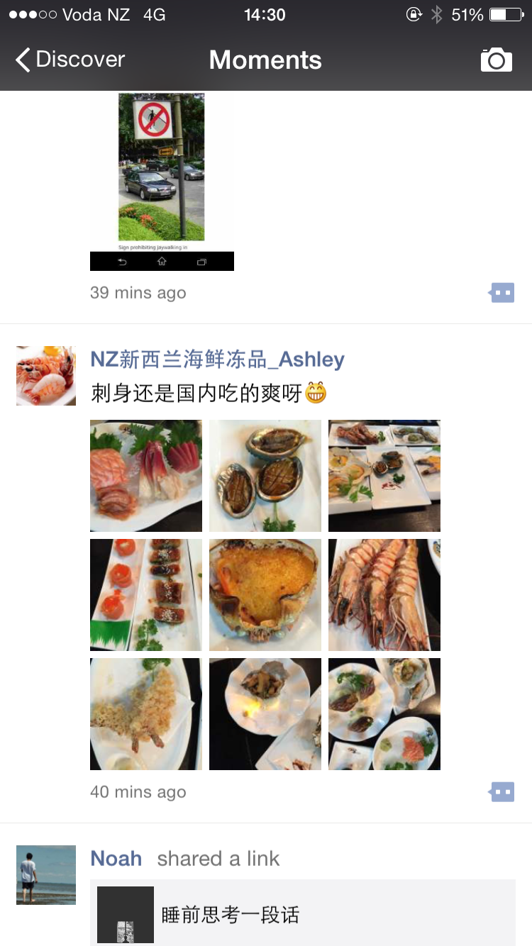

(2) “Scan QR Code” allow user to add new friend by QR Code

(3)”Shake” : User can shake their phone to add new friend when the other people shake their phone at same time.(Usually to add someone you don’t know at all)

1. “People Nearby”: User can use this funtion to search near by strangers. User can state their job on profile image and introduce their business.(Usually use to find potential cash buyer)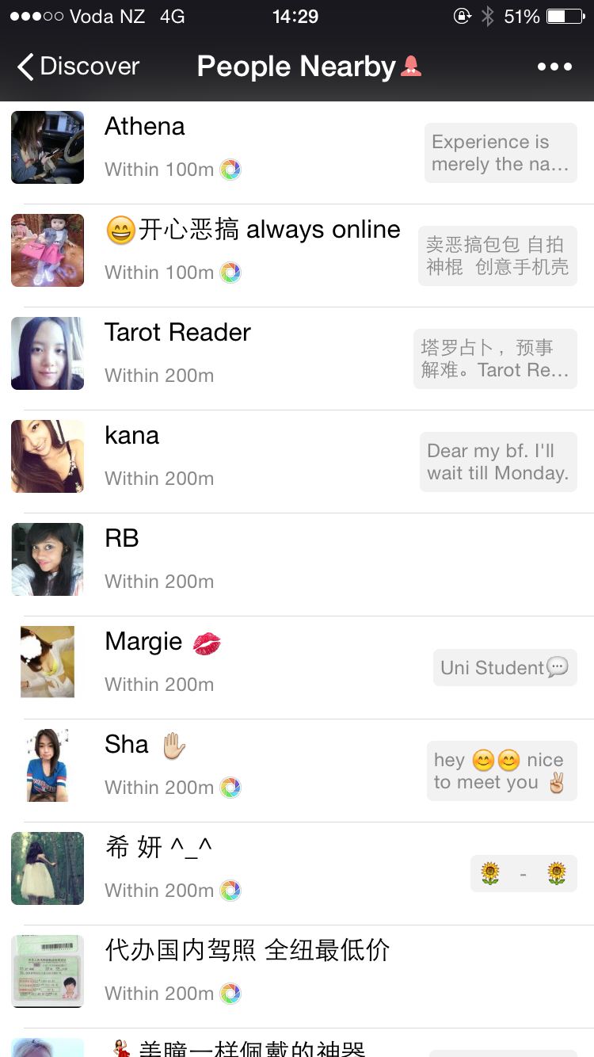
2. “Drift Bottle”: User can in put their voice or text massge into bottle and thoew into sea(internet) when some user pick up it they can listen and see your massage and reply.(user can pick up the bottle from all over the world who uses wechat)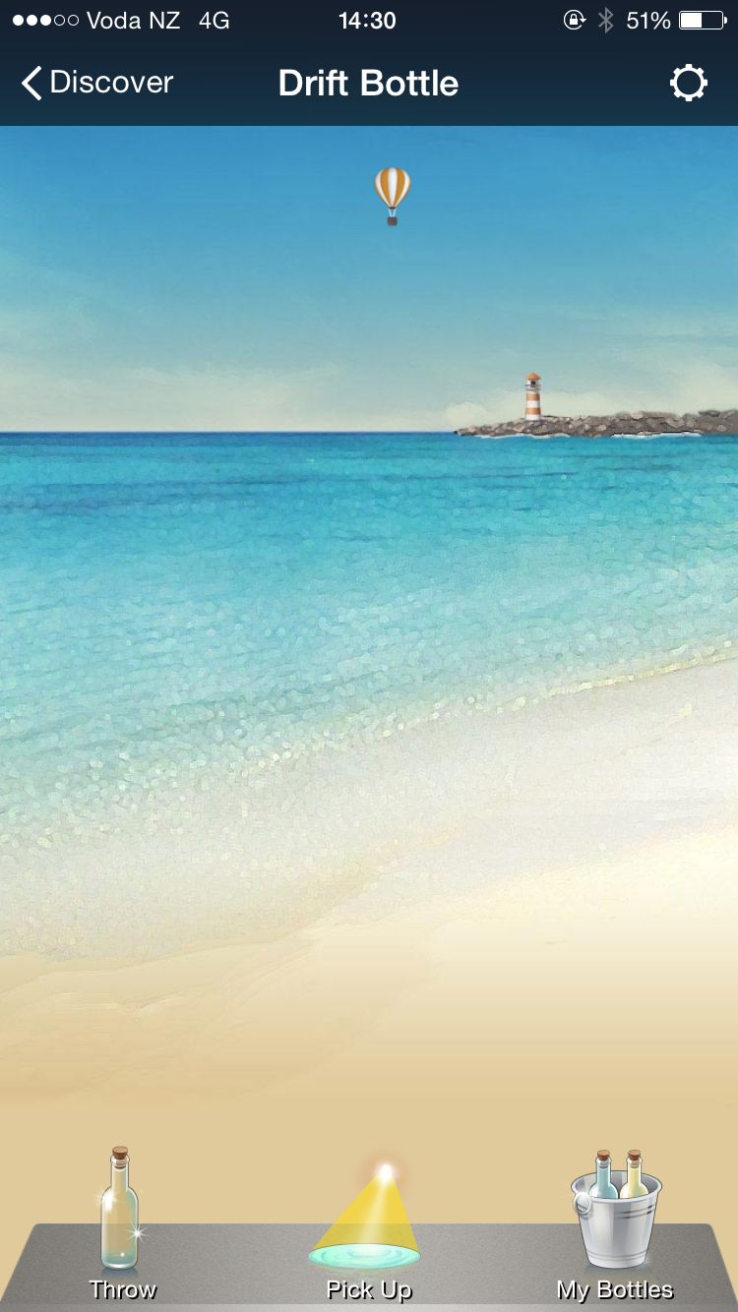

“Shake” “People Nearby” “Drift” use that three functions to exploer your new friends.

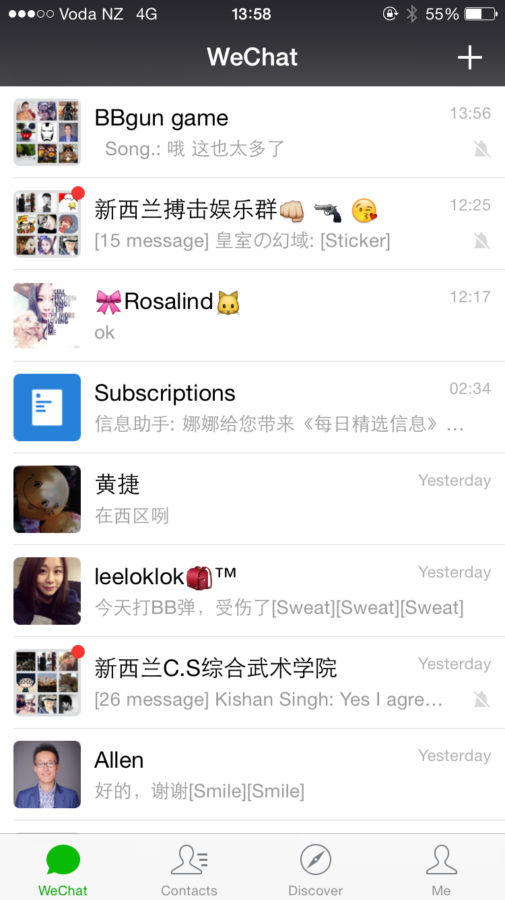

(1)This page is the main page of wechat

(2)Each picture present different chat with time. User can invite people from ther contact to creat multiple user chat( allowed Maxium 100 people to chat at same time)limitaion: everyone on the chat channl can invite others to join.also they can just add u to the chat channll without your permission.

(3) the “Plus” sympol on the top right is the function to add new friend. User can add people by Scan QR Code and Wechat/QQ /phone Contact number.

(4)On the botton of the main screen

“Wechat” is the main screen shows different chat channl

“Contacts” is the screen for friend list. Also u can find some official account to join.Offical account means the informaiton is update weekly(Example will follow Picture1)

1. “Discover” is the screen that allow user to explor new friends, post their momement and play games
2. “Me” is the screen allow user to change their profile image, check their posts, add favorites article they save before, check online banking, store Sticker Gallery(Different emotions and samll sticker”) and chage user settings such as disable post, block list and so on.

# How Wechat is helpful on Real Estae Market ?

Explan from differnet types of user agent, developer and purchaser.

Real Estate is a very big topic, so I will just choose flat bush as an example to explan how does Wechat is helpful on real estate market.

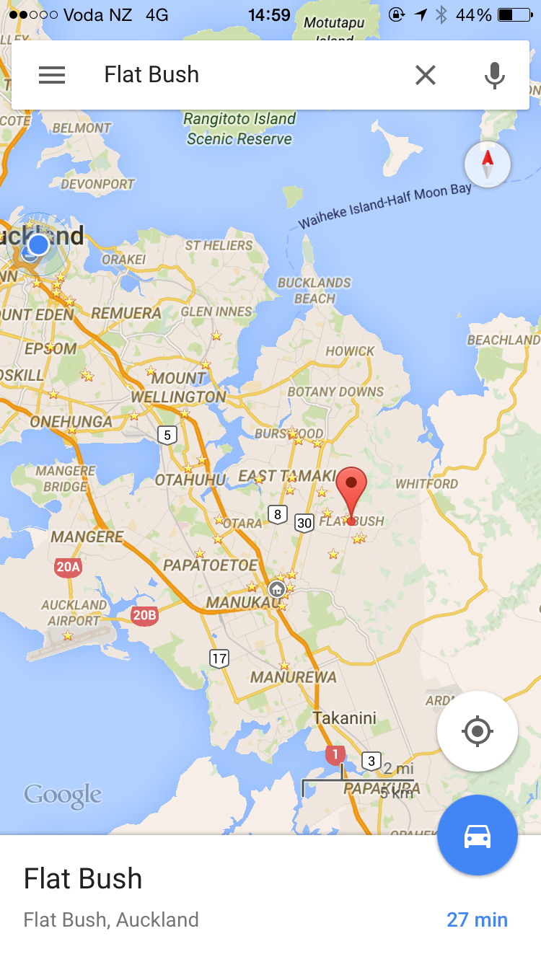

Agents can use Wechat to communicate purchaser and developer expically when they are Chinese it will make it more easier to get close to them. All these days, the business firm is looking for cash buyers. Agents could use people to find potential cash buyer around.

Also once the agent post his ads on “Moment” , then he can ask his friend to help him spred out which means that special “Moment” will spred out like virus everyone could see that piece of ads. Wechat is real time chatting tool once the person interesting on the propertie he can just add that agent’s wechat and start talk.

Developer. From this aspect questionare and interview method will be used to collect data which located on flat bush.

Purchaser. Once the agents has wechat account the purchaser to add multiple agents from different agencies such as Ray White, Barfoot,Parkuranga and so on.So purchser could get newest property’s information from them give more choice to buy property.

Some offical real estate news will be discussed on this topic and some other findings such as culture background, income, salary and so on will be presnet on final report.

# Case Study

A Case study form Starbucks of China called “ How one brand rocked Wechat to engage mobile users”

On this case study, the Chinese Starbucks use Wechat to promote thieir brand on the most popular messaging platform in China.

On the article, the Analytics Consultant compared Weibo(Microblogging in China, or Chinese based microbologing services. Some famous Weibo such as QQ Weibo, Sina Weibo, Phoneix Weibo and so on) Wechat stiil has some limits.

Firstly, the content on the Wechat is lack of details because Wechat is mobile phone based application compaere to computer. The small screen means enterprise have to foucs on presnet important information to audience. They have to conduct the content of an topic or ads make it become interesting and usful. Nobody want to read a long ads or article form small screen.

Sceondly, For Weibo it is possible to gain significant influence within short period of time. Some famous person open their Weibo allow people to follow them but not Wechat. Even wechat coverage and the inforamtin dissemination does not eaqul that of weibo, however in some points it still offers advantages to enterprise due to real-life users and mobile-based attributes.

Starbucks use three steps to otimize Wechat which are “Emoticon” “Morning Call” “Starbucks Calender”

“Emoticon”: After user add starbucks offical account they can send emoticon to stabucks as a result the user would receive the song from starbuscks according to the emoticon the user send. By the end of session the starbucks tallied 62000 fans on Wechat.

“Morning Call”: After the user download the app called “Morning Call” starbusck will promote newest of breakfast products to user. If user set alarm at 9AM on the morning then go to starbucks stores within one hour after alarm, they could join the new breakfast with half price.

“Starbucks Calender”: Starbucks clender algned with Chinese new year. This promotion encourge young person to participate the activities, including rising of chestnut and bear-hugging parents at starbucks. After the avtivities, the participter would receive a free-coffe and buy one get one promotion.

When use Wechat to do promotions the enterprise shoyld be care of the quality of content make sure the users interesting on it. Also Wechat establishs it as a strong customer service platform because it point-to-point communication.Service-oriented services is more suited to use Wechat because of it O2O(offline-to-offline)

Litetraue review